**Experiment 9**

**Lab Book:**



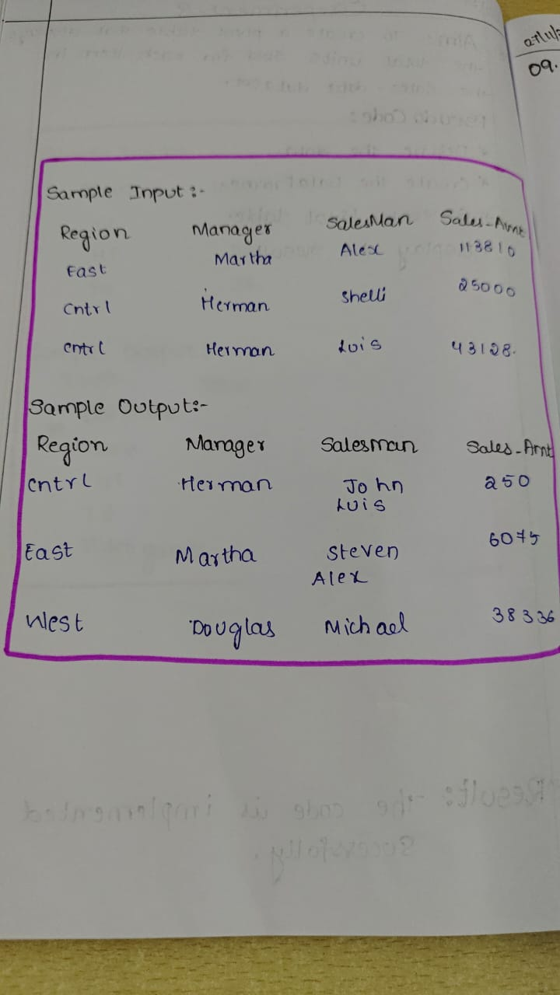

**Code:**

import pandas as pd

data = {

    'OrderDate': [

        '1-6-18', '1-23-18', '2-9-18', '2-26-18', '3-15-18', '4-1-18', '4-18-18', '5-5-18',

        '5-22-18', '6-8-18', '6-25-18', '7-12-18', '7-29-18', '8-15-18', '9-1-18', '9-18-18',

        '10-5-18', '10-22-18'

    ],

    'Region': [

        'East', 'Central', 'Central', 'Central', 'West', 'East', 'Central', 'Central', 'West',

        'East', 'Central', 'East', 'East', 'East', 'Central', 'East', 'Central', 'East'

    ],

    'Manager': [

        'Martha', 'Hermann', 'Hermann', 'Timothy', 'Timothy', 'Martha', 'Martha', 'Hermann',

        'Douglas', 'Martha', 'Hermann', 'Martha', 'Douglas', 'Martha', 'Douglas', 'Martha',

        'Hermann', 'Martha'

    ],

    'SalesMan': [

        'Alexander', 'Shelli', 'Luis', 'David', 'Stephen', 'Alexander', 'Steven', 'Luis',

        'Michael', 'Alexander', 'Sigal', 'Diana', 'Karen', 'Alexander', 'John', 'Alexander',

        'Sigal', 'Alexander'

    ],

    'Item': [

        'Television', 'Home Theater', 'Television', 'Cell Phone', 'Television', 'Home Theater',

        'Television', 'Television', 'Television', 'Home Theater', 'Television', 'Home Theater',

        'Home Theater', 'Television', 'Desk', 'Video Games', 'Home Theater', 'Cell Phone'

    ],

    'Units': [

        95, 50, 36, 27, 56, 60, 75, 90, 32, 60, 90, 29, 81, 35, 2, 16, 28, 64

    ],

    'Unit_price': [

        1198.00, 500.00, 1198.00, 225.00, 1198.00, 500.00, 1198.00, 1198.00, 1198.00,

        500.00, 1198.00, 500.00, 500.00, 1198.00, 125.00, 58.50, 500.00, 225.00

    ],

    'Sale_amt': [

        113810.00, 25000.00, 43128.00, 6075.00, 67088.00, 30000.00, 89850.00, 107820.00,

        38336.00, 30000.00, 107820.00, 14500.00, 40500.00, 41930.00, 250.00, 936.00, 14000.00,

        14400.00

    ]

}

df = pd.DataFrame(data)

pivot_table = df.pivot_table(values='Sale_amt', index=['Region', 'Manager', 'SalesMan'], aggfunc='sum')

print(pivot_table)

**Sample Output**

